Azure Repo Git Setup Guide

This guide will help you to setup the Azure Repo working environment. This will enable you to easily synchronise your work into the main repository.

# Contents:

* SETUP
* USAGE
  + Synchronising (Pull)
  + Commit and Push changes

# SETUP:

1) Download and Install Visual Studio Code. This will be your main code editor for React Native apps. You can download it at <https://code.visualstudio.com/>

2) Install Git. Git will be used to retrieve (pull) the repository’s files and send (commit & push) your work/changes to the main repository

3) Once you have installed both Visual Studio Code and Git, it is time to clone the repository to your machine.

1. Open Visual Studio Code and head to the Source Control tab on the sidebar.

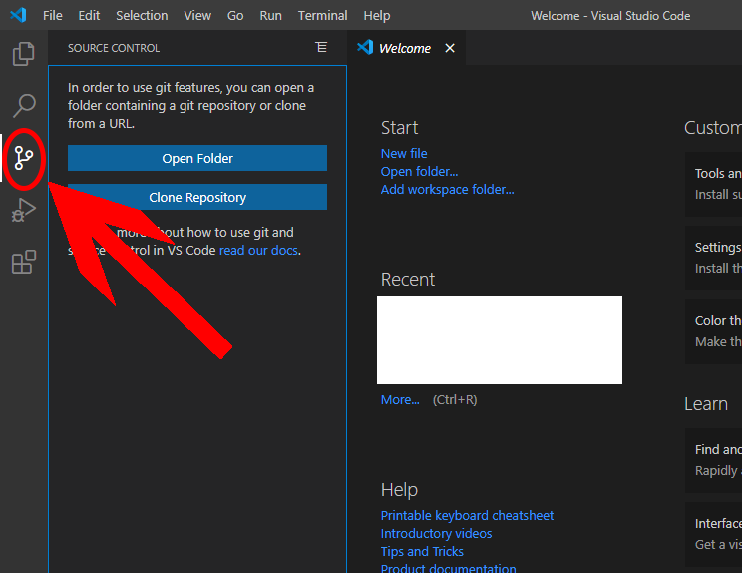

Upon selecting the Source Control tab, you should see the “Clone Repository” button.

1. Click on the “Clone Repository” button and a popup should appear at the top

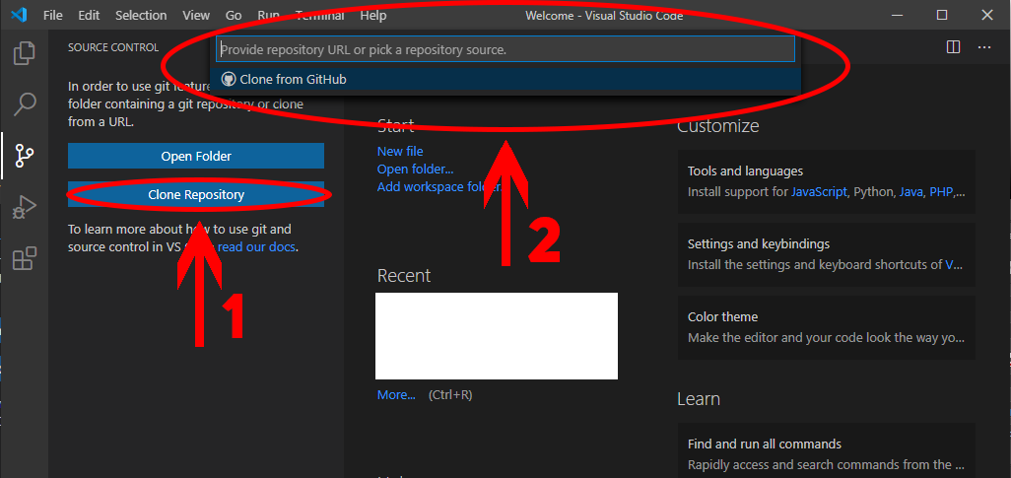

1. You will now need the link from the LionPortalMobileP2 Repo website. Go to <https://dev.azure.com/nypmobile/LionPortalMobileP2/_git/LionPortalMobileP2> and go to the Repos tab on the sidebar.

(A Log In might be required. If so, log in to your school account)

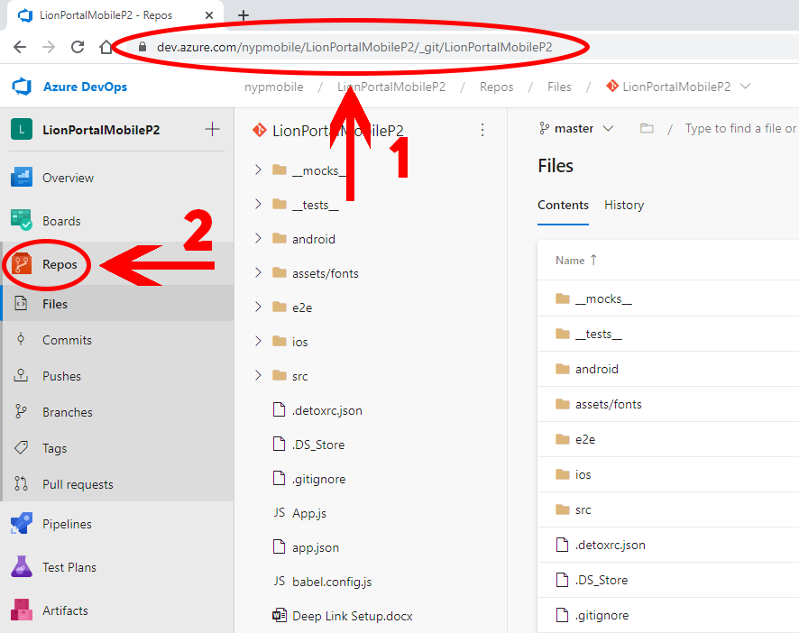

1. Next, in the Repos page, press the ‘Clone’ button located on the right of the page. This should open up a ‘Clone Repository’ pop-up. Copy the HTTPS link.

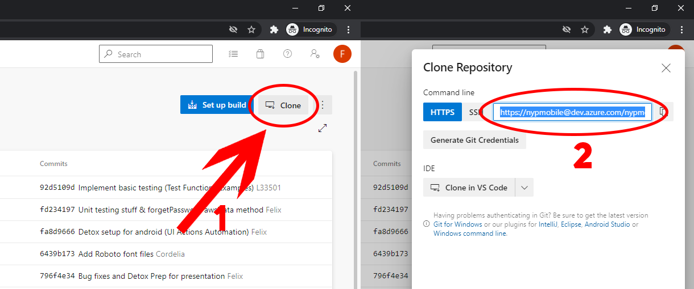

1. Go back to Visual Studio Code and paste the link into the pop-up box. Hit Enter.

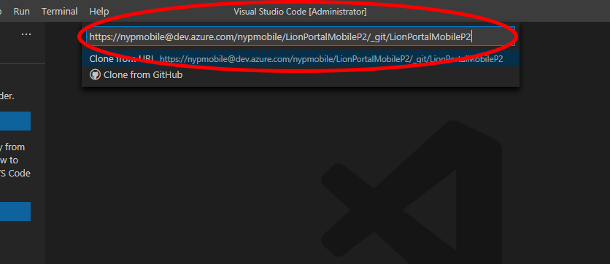

1. A File Explorer window will appear. Select the location to save your project.

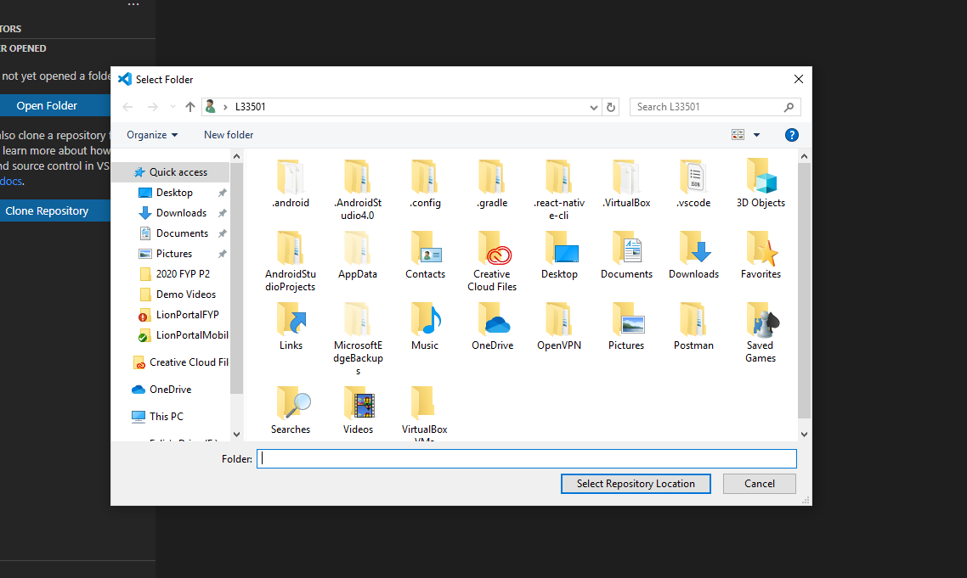

1. Visual Studio will start downloading the Repository. (A log-in pop-up may appear. If so, a log in is required. Log in to your account)

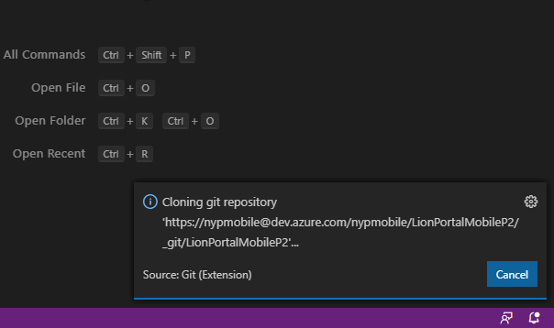

1. Once the download is finished, you can open the cloned repository.

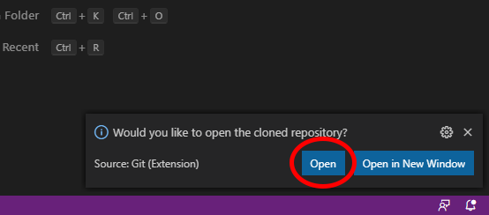

1. DONE! You can start working on your project!

# USAGE:

As this repository folder is now linked to the repository in Azure, you can easily submit your work in Visual Studio Code.

## Synchronising (Pull)

To keep your local folder up-to-date with the repository in Azure, you will need to synchronise your folder.

Example: When your teammate has done changes and submitted his work, you would need to synchronise your local folder to see his changes in your local folder.

1. At the bottom of the screen, press the Sync button. Visual Studio Code will start updating your local folder to match the one in Azure

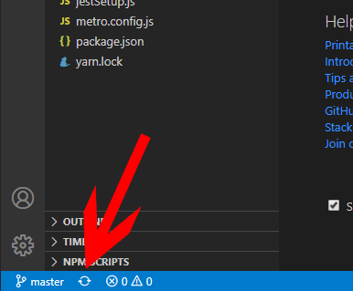

## Commit and Push changes

Once you have made changes to the codes, you will need to send them to the Azure Repo. You can do this by committing the changes and pushing them.

1. In the Source Control tab, select which files you would want to submit the changes by pressing the “+” icon

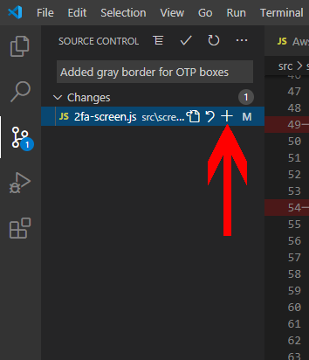

1. Add a message that describes what this change is about

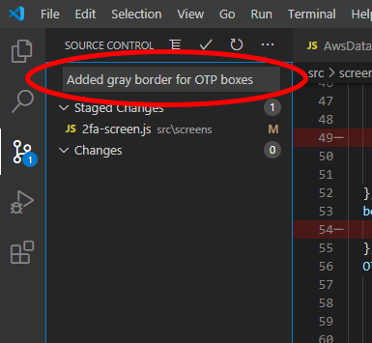

1. Press the tick button to commit these changes

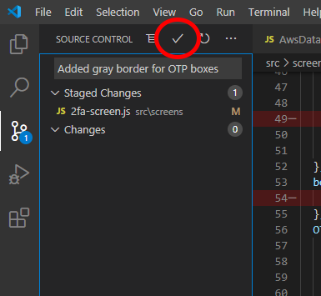

1. Press the synchronise button at the bottom of the screen to push these changes to the Azure Repo

